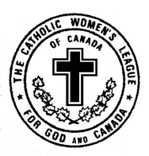
The Catholic Women’s League of Canada

Alberta Mackenzie Online Membership Form

Name:

Address:

City/Town:

Postal Code:

Telephone:

Email:

How did you hear about the Catholic Women’s League (CWL)?

Note: Memberships are gathered and submitted from a parish council level and there will be an annual membership fee payable to the parish council. Your submitted form will be forwarded to the appropriate parish council.

Which parish do you belong to or live closest to?

Please email your completed form to:
cwlabmk@cwl.ab.ca

